AURORA​ ​MULTIMEDIA​ ​Introduces​ ​HT​ Series​

​Unshielded ​HDBaseT®​ ​4K60​, 4:4:4​, 18Gbps

MORGANVILLE, NJ June 6, 2018, (InfoComm 2018, Booth C2146) — Aurora Multimedia redefines HDBaseT with many new industry first capabilities including the ability to work at 4K60 4:4:4 with a single unshielded CAT 5e or better cable and the world’s first Dante® option for 2 or 8 channel Dante.
Three new HDBaseT 2.0 products comprised of the HTW-2 two gang transmitter Decora wall plate, HTE- TX2 transmitter box unit, and the HTE-RX2 receiver box unit will change the way HDBaseT is utilized.

All products are capable of transmitting 4K60 4:4:4 18Gbps HDMI 2.0/HDCP2.2 100m (330ft) over a single unshielded CAT cable with no quality compromise and with zero frame latency. In addition, all products have an integrated web server for remote IP control, USB 2.0 with directional control, and the world’s first Dante option for 2 or 8 channel Dante. For enhanced audio, the HT Series supports ARC (Audio Return Channel). To further simplify the installation, the HT Series can power both TX and RX from a single port of a PoE Switch eliminating external power supplies.

The HT Series also supports the new ReAX™ IP Control engine option (IPE-REAX-1) base on Javascript™. ReAX allows full IP control automation throughout the network without the need of an external proprietary control engine. For more information www.reax.org

“The new Aurora HDBaseT products will further enhance the capabilities of HDBaseT and simplify installations especially with point to point installations,” says Paul Harris CEO of Aurora.

For further information e-mail sales@auroramm.com or call 732-591-5800.
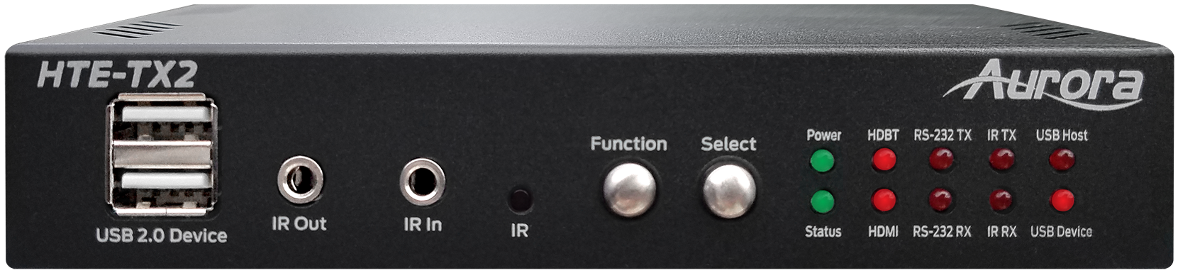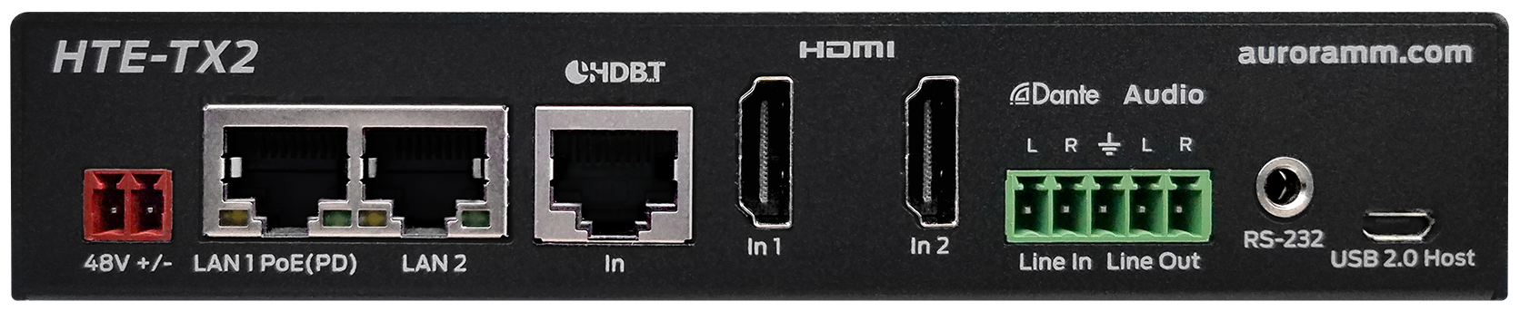
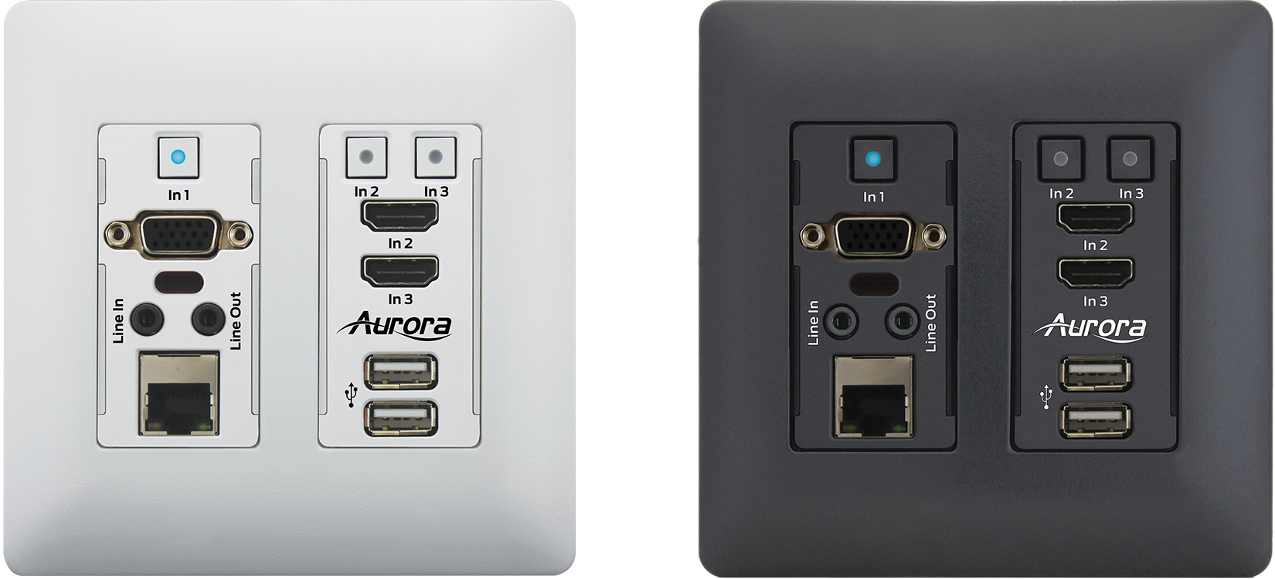

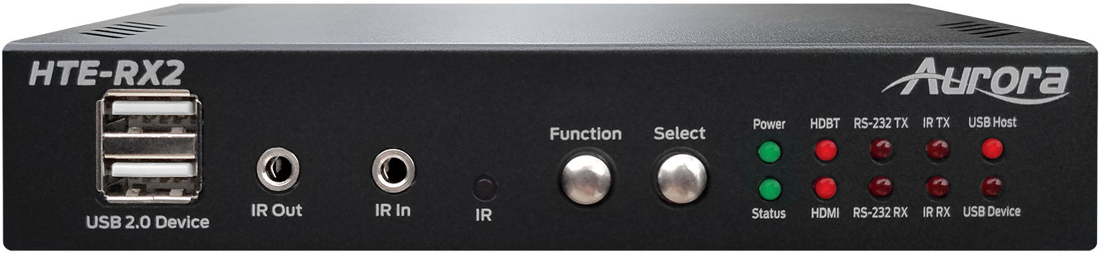
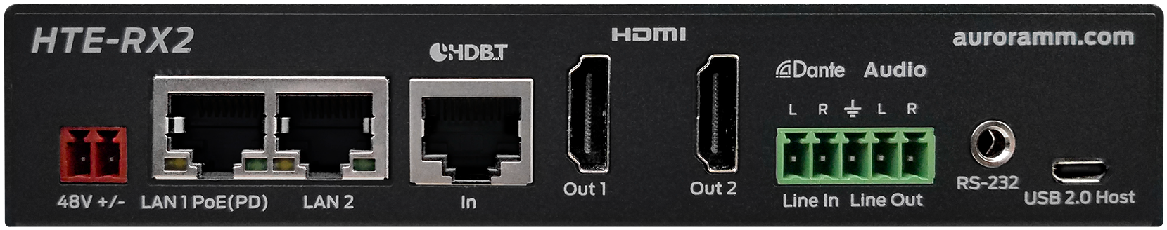

About Aurora Multimedia:
Aurora Multimedia products incorporate state-of-the-art technologies that surpass typical specifications and features. From the introduction of the industry’s first non-proprietary, Web-standards-based IP control systems and touch panels, to today’s advanced HDBaseT™ and IPBaseT® IP video distribution solutions – has made Aurora a dominant force in the AV industry. Advanced AV processors with scaling, multi-image rotation, and dual/quad display processing only add to our highly adaptive, diversified product line. Aurora provides solutions for a variety of global markets, including government, education, security, hospitality, corporate, and house of worship. www.auroramm.com

Marketing Contact: marketing@auroramm.com

