AURORA MULTIMEDIA’S IPBaseT® 10Gbps, 4K AV over IP,
Transceiver IPX-TC3

MORGANVILLE, NJ June 6, 2018, (InfoComm 2018, Booth C2146) — Aurora Multimedia will be demonstrating the only encrypted 4K60 4:4:4 10Gbps AV over IP transceiver, utilizing their Patent Pending IPBaseT® technology based on the BlueRiver NT+ platform. The IPX-TC3 compliments the growing line of IPX Series 10Gbps products. Aurora is changing the topology of AV resolving all existing issues with reliability, serviceability, scalability, capability, and inventory.

The IPX-TC3 is the World’s First 10Gbps IPBaseT® transceiver capable of 4K60 4:4:4 with a frame latency of only 100us (.1ms) offered in copper and fiber. The IPX-TC3 is the first ever 10G SDVoE product to have redundant fiber version and selectable copper fiber in a single unit. Aurora is also the first company to utilize PoE with 10G and has worked with Ethernet switch companies to develop and ship 10G PoE switches paving the way for cleaner installations.

Aurora’s latest combines a variety of IP technologies and features under one uniﬁed protocol using a simpliﬁed topology. Seamless switching, USB 2.0 (480Mbps), Dante®/AES67 8-channel (another Aurora first), 1Gbps Ethernet, and control are some of the core capabilities of IPBaseT®. The IPX-TC3 also supports dual OSD (On Screen display. This allows for content to be generated at the encode and decode sides.

The IPX-TC3 also supports the new ReAX™ IP Control engine option (IPE-REAX-1) base on Javascript™. ReAX allows full IP control automation throughout the network without the need of an external proprietary control engine. For more information www.reax.org

Powerful hardware needs powerful software to compliment. The IPBaseT® Manager allows full set up and control of all functions. Key features are the EDID editor allowing for full manipulation of an EDID to create common denominators and Rapid Deployment Tool (RDT) which can fully configure a large system in minutes.

Utilizing the bandwidth of a standard 10Gbps copper or ﬁber, the IPBaseT® IPX Series supports large scalable audio/video matrixing, and it does so while replacing multiple technologies and products with a "single-box" distributed platform.

For further information e-mail sales@auroramm.com or call 732-591-5800.
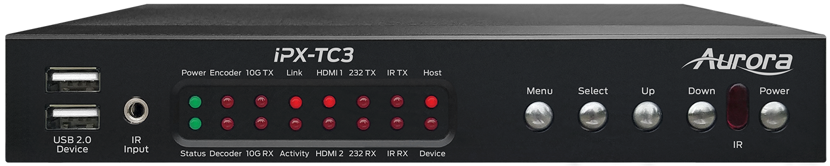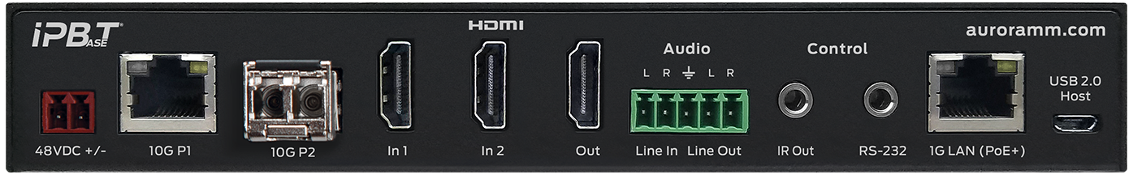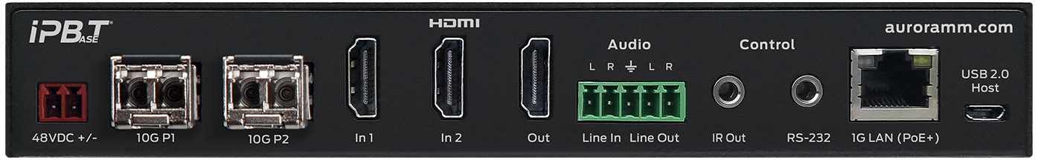

About Aurora Multimedia:
Aurora Multimedia products incorporate state-of-the-art technologies that surpass typical specifications and features. From the introduction of the industry’s first non-proprietary, Web-standards-based IP control systems and touch panels, to today’s advanced HDBaseT™ and IPBaseT® IP video distribution solutions – has made Aurora a dominant force in the AV industry. Advanced AV processors with scaling, multi-image rotation, and dual/quad display processing only add to our highly adaptive, diversified product line. Aurora provides solutions for a variety of global markets, including government, education, security, hospitality, corporate, and house of worship. www.auroramm.com
Marketing Contact: marketing@auroramm.com

