For more information, contact:
Steve Doran
Marketing Manager
Bogen Communications, Inc.
(201) 995-2061
sdoran@bogen.com

FOR IMMEDIATE RELEASE

InfoComm 2019 Orlando, FL - Booth 6543

Bogen To Showcase Latest Innovations at InfoComm 2019 in Orlando, FL

June 10, 2019, Mahwah, NJ – Bogen Communications, Inc. will be showcasing several new products and solutions at InfoComm 2019 in Orlando, FL, including the recently-launched C4000 Series IP-Based Paging and Audio Distribution Solution, the latest 4.0 release of the E7000 Series IP-Based Communications Solution for schools, and the Apogee ALA-C1 Line Array Loudspeaker.

C4000 Series IP-Based Paging and Audio Distribution Solution
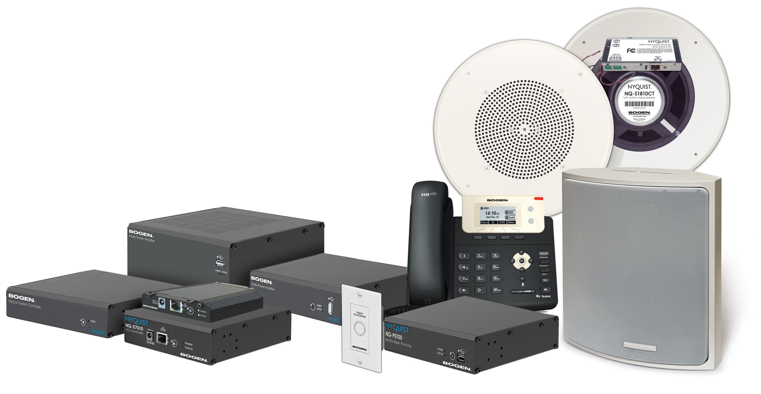

The C4000 Series solution was began shipping in March 2019 and follows Bogen’s award-winning E7000 Series solution for educational markets that debuted at InfoComm 2017. Both products leverage Bogen’s Nyquist software platform that provides users with unparalleled flexibility and scalability in whatever their application. The C4000 system addresses the unique communication needs of a variety of users: business, commercial and industrial facilities, transportation hubs, healthcare, retail, hospitality, entertainment, houses of worship, and government — anywhere easy and effective communication and audio distribution are required.

The heart of the C4000 solution is the feature-rich Nyquist C4000 application software with an intuitive, easy to configure Web-based Graphical User Interface (GUI) that is accessible from any PC, tablet, or mobile device. The application software is available either preinstalled on Bogen’s Nyquist System Controller, or integrators can install it on any Intel X86 based server platform. Purpose-built appliances provide audio mixing, amplification, and distribution, as well as the ability to easily integrate with third-party devices and systems, such as PBXs, access control, and fire alarm. Users can easily create a turn-key solution with networked appliances that include seven new audio power amplifiers, ranging from 1-channel x 20 Watts to 4-channel x 300 Watts, as well as a 4-channel matrix mixer/pre-amp. A versatile new 10-Watt plenum-rated VoIP intercom module allows users to turn any speaker into an IP speaker for even greater site design flexibility.

The C4000 Series solution also features a built-in, streaming Internet radio service, airable by TuneIn. Business users can also access commercially licensed, customizable, curated music stations from SoundMachine, the premier music subscription service for businesses. Both services are perfect for a wide variety of background music applications. SoundMachine gives large and small retailers, restaurants, bars, or any other company looking to enhance their customer experience the ability to craft a seamless, engaging, and on-brand music experience.

The C4000 Series solution is extremely easy to install and use. Its web-based GUI allows people with a broad spectrum of technical proficiency to use the system. The C4000 Series solution can be scaled to support multiple, geographically dispersed facilities, encompassing a virtually unlimited number of paging and audio zones. Talkback capability is available for any areas requiring two-way communications. The solution can be easily upgraded with new features over time to address ever-changing customer environments and technology.

E7000 Series IP-Based Communications Solution for Schools v.4.0
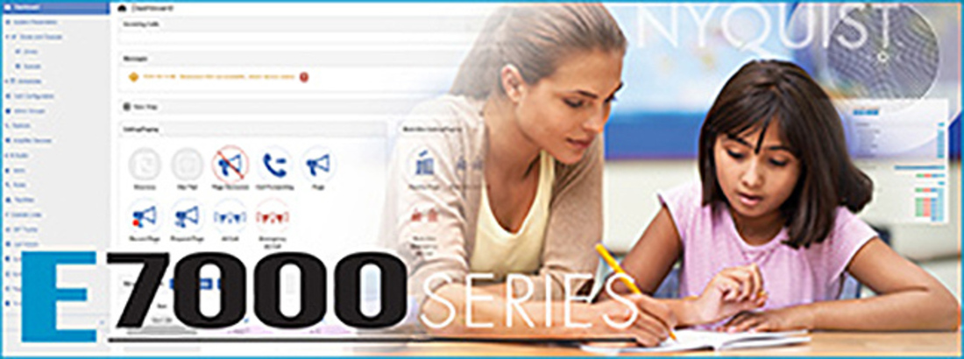

Bogen is pleased to announce the forthcoming end-of-June release of version 4.0 of its award-winning E7000 Series IP-based paging and intercom solution based on its Nyquist software platform. This latest release demonstrates Bogen’s commitment to continually enhance the E7000’s core features and capabilities. New v.4.0 features include:
- IP-Based Clock/Messaging Display
- Emergency Check-In
- User-Definable Routines for
- Lockdowns
- Weather Events
- Fire Drills and Evacuation Procedures
- Automated Notifications
- And More

These new features follow up on the innovations to the E7000 solution released in December 2018 as part of version 3.0, which included: Nyquist System Controller support, wizard-based system setup and configuration, two-channel networked audio amplifier support, integrated pro-audio digital signal processing, ambient noise sensing, page stacking/queuing, integrated internet radio program source, integrated SoundMachine subscription-based premium streaming music service, scheduled audio distribution from any source, and recurring scheduled announcements.

Apogee ALA-C1 Line Array Loudspeaker
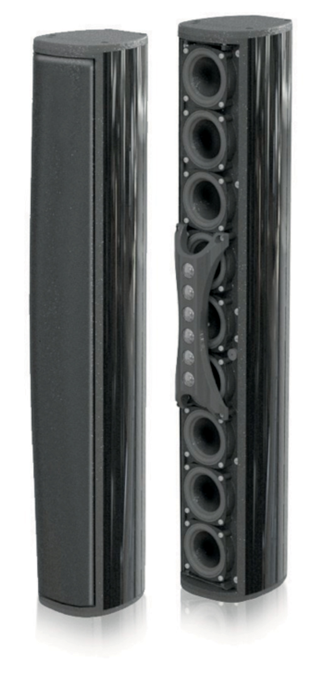
The Apogee ALA-C1 Line Array Loudspeaker is a high- fidelity, 70V/8-ohm, passive, 2-way fixed column, all- weather, indoor/outdoor loudspeaker designed for superior quality speech enhancement and music reproduction in small- to medium-sized venues, such as school and civic auditoriums, community theaters, lecture halls, and houses of worship. The design offers extremely broad horizontal dispersion (140-degrees) and focused vertical dispersion (25-degrees) – which is ideal for uniform side-to-side coverage, while minimizing ceiling and floor reflections that could degrade intelligibility. The ALA-C1 is an award-winning product from Bogen’s Apogee Sound International brand of professional audio solutions. It will be commercially available in the 4th quarter of 2019.

“As a truly market-driven provider of audio and communication solutions we rely heavily on feedback from our distributors, dealers and integrators, so awards like these tells us that Bogen continues to deliver on our commitment to provide technologically-advanced solutions to our integrators and end-users in accordance with evolving market conditions” said John Minnick, Bogen’s Vice President of Engineering.
“This is the second time in 3-years that a solution based on our Nyquist platform has received recognition as a market-leading solution at InfoComm which is testimony to its flexibility, scalability and rich feature set.”

Bogen will be conducting live demonstrations of the C4000 Series solution, the E7000 Series v.4.0 features, and the ALA-C1 at InfoComm Booth #6543.

About Bogen
For more than 87 years, Bogen Communications, Inc., has been a leading provider of commercial amplifiers, speakers, and intercom systems for music, paging, and educational applications. For more information, contact Bogen Communications, Inc., 1200 MacArthur Blvd., Suite 304, Mahwah NJ 07430-2331; 201-934-8500, fax: 201-934-9832, e-mail: info@bogen.com, websites: www.bogen.com; www.bogenedu.com (IP and analog education communication solutions) and www.bogen-ip.com (IP commercial paging and audio distribution solutions). You may also visit our InfoComm virtual press office at http://infocomm.vporoom.com/bogen.

About SoundMachine
SoundMachine brings commercial background music to the fore with a subscription-based service that gives business owners everything they need to create an engaging, on-brand music experience. SoundMachine serves more than 10,000 locations internationally, with customers including major fashion luxury brands such as Loewe (LVMH Group) and La Perla; hotel, restaurant, and coffee chains; and thousands of medium to small businesses. For more information go to https://www.sound-machine.com.

About airable by TuneIn
airable – TuneIn knows music, web radio stations, podcasts, audio on demand and Internet media. The airable technology enables apps and devices to meet the changing and challenging online media expectations of today’s consumers. Consumers access the airable catalogues and services via devices of exclusive consumer electronics manufacturers and apps. c400airable – TuneIn GmbH is privately held and was founded in 2010 with offices in Germany and the United States. For more information go to http://www.airablenow.com/airable/.

###

