FOR IMMEDIATE RELEASE
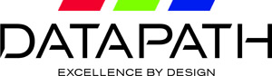

DATE June 2017

Datapath introduces Quant application-sharing software

Datapath, world-leading engineers of visual solutions, is unveiling advanced application-sharing software for mainstream video wall users working in collaborative business environments, along with operation centres and control rooms. The unique capabilities of Quant allow users to view and share applications, as well as interact and make changes to original source files. Quant, which can work in stand-alone mode or in conjunction with Datapath’s WallControl 10 software, is being released following the acquisition of its original developers, MOSAIQQ Inc, earlier this year.

Offering wide, cross-market appeal, Quant has been designed for users to collaborate, assign and delegate tasks instantly, in real-time, without the need for the cloud. Providing full interactivity with shared applications, Quant permits application windows to be dragged and dropped between peers or on to a video wall. This intuitive functionality makes it easy to share important information from sometimes ad-hoc sources ‘on the fly’, saving time and expanding the usability of video walls. Additionally, it can be configured in a more permanent way to share information.

Quant also offers simultaneous interactivity within the same application by multiple users, as well as instant synchronisation between peers in a group, including those running video walls. What’s more, the end user can mix and match sources regardless of where they originate from.

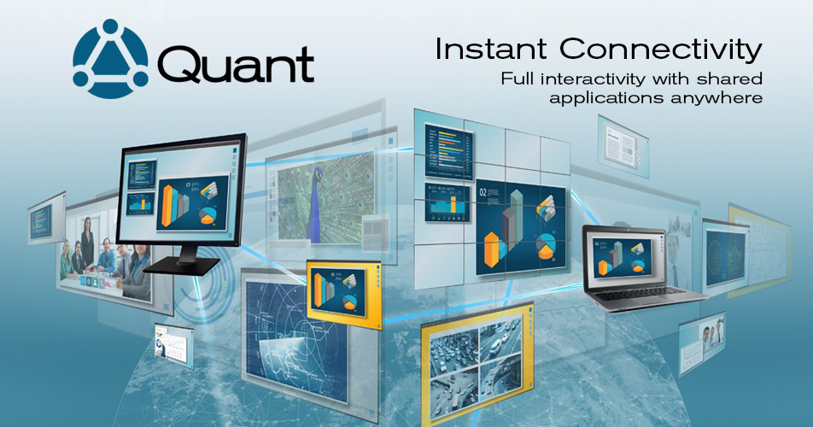
The software, which contains patented and patent-pending technology, provides complete security as the user has full control over each application, deciding what to share, with whom, and what permissions are given. Any changes are synchronised instantly, meaning updates made by multiple users are seen as they happen.

As Quant is ideal for connecting people through shared application windows, sectors set to benefit include business collaboration, traffic management centres, manufacturing process control centres, utility service operations and security suites.

“Ultimately, optimised application sharing is about to advance into the mainstream video wall market,” states Bjorn Krylander, Managing Director of Datapath. “With a couple of clicks this new software provides interactive capability. It is possible to move content using drag and drop functionality from an application window to another user or video wall, thus sharing it instantly. This capability will be highly valuable to control rooms, meeting rooms and collaborative/information sharing environments which have more responsive needs. In short, instant connectivity has never been so simple.”

Quant will be available to purchase as a starter pack, containing the Quant configuration server plus five workstation licences. Additional licences will be available in bundles of five, 10, 25 and 100.

The software offers full compatibility and integration with WallControl 10, industry-leading software that provides users with the interface required to quickly and effectively manage content such as video captures, IP streams and local applications.

-THE END-

About Datapath Limited

Datapath Limited – engineering the world’s best visual solutions. By listening carefully to customers, continuous improvement, and putting quality in everything we do first, Datapath solutions are Excellent by Design.
Founded in 1982 and now distributing across 5 continents, Datapath has customers in more than 100 countries Worldwide; covering multiple industries such as professional audio and video, military, education, security and health care.
Datapath is a privately held company, with head office in Derby, UK, and sales and support offices in USA, France, Japan, and China.

Media Contact: Kay Mumford
Media Contact Details:
T: +44 (0)1332 294441
E: kay.mumford@datapath.co.uk
A: Datapath Ltd, Bemrose House, Bemrose Park, Wayzgoose Drive,
Derby. DE21 6QX

