NEC Showcase 2016 – London UK.

The NEC Showcase comes around every 12 months and has to be one of our favourite events of the year here at Green Hippo. Always held in an interesting location, this year saw NEC take over floors 28 and 29 of the iconic Milbank Tower down on the Thames within spitting distance of Big Ben and the MI5 building. The spectacular views only added to what was a very successful two days of all things displays related.

At ground floor level, a fabulous 4-minute presentation, The NEC Experience, hinting at what was to be found at the top of the tower was implemented by a very creative 3D mapping piece onto a model of London’s cityscape using a Green Hippo Hippotizer media server and our latest version of SHAPE 3D mapping software. Working together with Made Up, Harman, Peerless and Atlona, the show was a spectacular awakening of the senses and the perfect way to create enthusiasm for what lay ahead at the show.

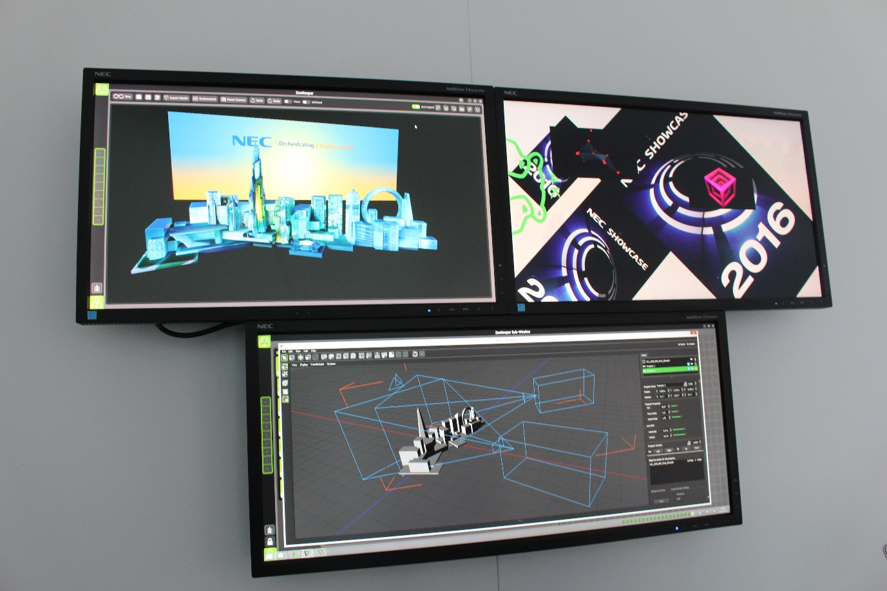

The layout of the NEC showcase is always ingenious. Feeling a little bit like a displays industry take on Ikea, the normally open floors of Milbank Tower were turned into a route around the venue where attendees pass through every zone without exception. Our presentation area was the final one on the 29th floor but unlike being at the back of a tradeshow hall, this was no hindrance. We had traffic all day since the final exit was right next to us. Whilst this may sound a little controlling it really isn’t. One noteworthy attribute of the NEC staff is that they’re not only knowledgeable and focussed, they’re also jolly nice folk too! Rather than being left to wander and wonder, visitors were assigned a chaperone from their respective field who guides them through the well laid out sections and sectors. This gave companies partnering with NEC a chance to be properly introduced to visitors by someone who knows them via an existing customer/client relationship. With the event divided into key market sectors such as education, transport, retail and so on, the clients got to see exactly what they need to see swiftly and efficiently.

The term ‘partner’ is often overused but at the Showcase event it is actually a fair description. By inviting key companies from each industry sector to bring along their source systems and feed their signals into NEC product, the event really does show how this partnership works. In our lounge area on the 29th floor we demonstrated our AViary Video Tools’ prowess with an impressive 7 screen layout of wall-mounted screens at arbitrary angles all driven by our Par4Keet player. The constant flow of potential and existing clients through our area allowed us to demonstrate how, with one system and two Display Port cables (thanks to NEC’s powerful implementation of loop through), we were able to feed a canvas made up of 2 x 4K with rich, smooth high resolution content without any editing of media, no video wall controller, all scaled and coloured without the need for a vision mixer of any kind. With the screens positioned on the opposing side from our control zone, we used a single network cable to access all features of the server using BirdKeeper software on a laptop remotely. Using VideoMapper inside the BirdKeeper software, we were able to map video to the jauntily angled screens with ease and with a line-up time of around 15minutes.

One of our favourite elements of any NEC Showcase is that almost all partners use the same NEC media, supplied by their marketing team. Being able to walk through a show and see how all the different systems handle playback of identical media is a fabulous way to sort the men from the boys and allow potential buyers to do a true quality assessment throughout the venue from start to finish; something we welcome since we at Green Hippo pride ourselves on the quality of our playback at all resolutions up to 4K and beyond.

Alongside the AViary setup, we ran a simulation of the ground floor 3D NEC Experience to allow people to see how we implemented this 3D mapping project in Hippotizer software and how easy it is to create stunning visual spectacles on buildings and other non-linear surfaces with SHAPE.

With a networking drinks reception at end of play on both days and plenty of areas to sit and chat about forthcoming projects, the NEC Showcase was, for us, once again a huge success. We’re looking forward to discovering which fabulous London venue will host the event in 2017.

James Ross Heron
AViary Business Development Director

