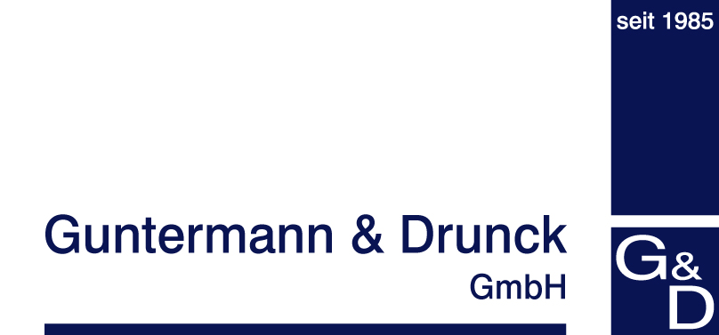

Press Contact:
Jochen Bauer
Guntermann & Drunck GmbH
bauer@gdsys.de

Obere Leimbach 9
D-57074 Siegen
Phone +49 (0) 271/23872-100

05/19/2017

G&D at InfoComm2017
4,796 characters incl. spaces

If published, please send me a copy or digital copy
with link.

The use of the images is allowed only in connection
with the press release.

InfoComm 2017 – it’s all about 4K and 8K

The world’s first and only KVM extender to transmit 8K video – made in Germany

With a suitcase full of product innovations, this year again Guntermann & Drunck GmbH and its subsidiary G&D North America Inc. will travel to Orlando, FL to participate in InfoComm 2017, the largest annual conference for AV buyers and sellers in the Western Hemisphere. Visitors can expect various next-generation KVM solutions and the market’s broadest KVM product portfolio.

One of these smart solutions is the KVM extender DP1.2-VisionXG. The system of superlatives makes it possible to transmit 4K and 8K resolutions at a refresh rate of 60 Hz over large distances – uncompressed, loss-less and without any latency. The KVM extender system consists of a computer module and a user module. It allows users to operate their computers remotely while benefitting from the pixel-perfect, uncompressed transmission of high-resolution DisplayPort videos over distances up to 10,000m. The device is available in variants with up to four video channels. Thanks to the source synchronicity of the video channels, even extremely high video resolutions such as 4K and 8K can be extended over long distances.
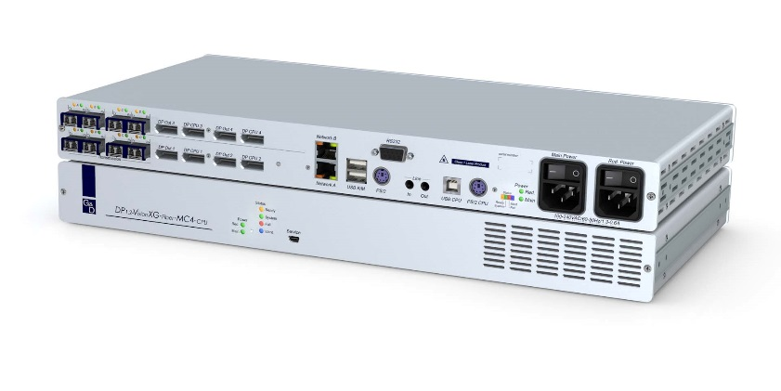
KVM extender DP1.2-VisionXG-MC4 for perfect video transmission, pixel by pixel, for 4K and 8K at 60 Hz.

Pixel-perfect and latency-free
The DP1.2-VisionXG uses optical fibers for the dedicated transmission. Thus, the system provides enough bandwidth for uncompressed, high-resolution DisplayPort 1.2 video signals, keyboard/mouse, RS232, USB2.0, and audio.

With a network port, an intuitive web interface, monitoring, syslog, SNMP, screen freeze function and a redundant power supply, the DP1.2-VisionXG offers numerous features for mission-critical applications.

Loss-less and pixel-prefect transmission even for compressing KVM systems
At InfoComm 2017, G&D will also introduce the KVM extender DP1.2-Vision, which uses the in-house HDIP compression technology in the latest development stage, Level 3. This compression mode allows the loss-less transmission of video signals with a resolution of 4K at 60Hz. Thus, the systems require less bandwidth to transmit signals – but still provide clear and visually lossless images and a latency-free operation. The DP1.2-Vision supports the transmission of DisplayPort1.2 signals, which takes place either via CAT cables over distances up to 140 m or via optical fibres to 10,000 m.

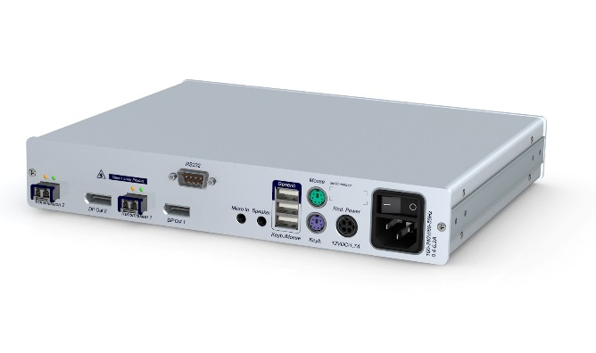
KVM extender DP1.2-Vision: Data transmission over fibre optics or CAT cables.

Switching 4K resolutions via matrix systems
The advantage of a lower bandwidth and a compressed image transmission: Video signals can be better processed and switched. Thus, the KVM extender DP1.2-Vision can be combined with a matrix application and 4K signals can be distributed by matrix systems. KVM matrix systems allow the independent and remote operation of multiple computers over multiple, simultaneous consoles.
Even with different features, all G&D products are compatible and can be combined. Thus, the KVM extender DP1.2-Vision can easily be integrated into G&D matrix systems such as the ControlCenter-Compact or the ControlCenter-Digital, which allows the extension and switching of 4K at 60 Hz through the matrix.

Versatile functions for flexible operation
G&D matrix systems feature a range of mission-critical and user-friendly features, such as CrossDisplay-Switching, the push-get function and scenario switching to make the work of the all users as efficient and as comfortable as possible.
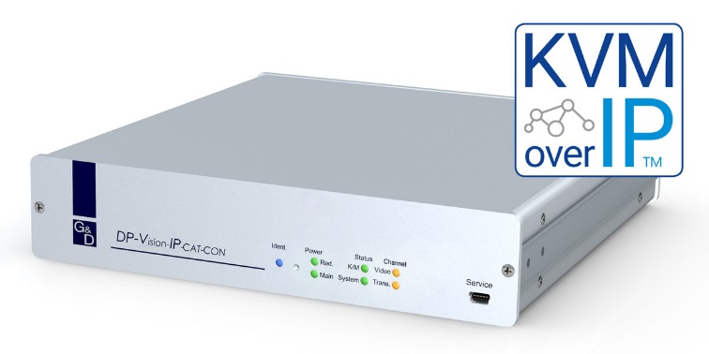
DP-Vision-IP for unlimited access over IP.

Unlimited access with KVM-over-IP™
The latest member of the G&D KVM family is the DP-Vision-IP, a KVM extender based on IP structures.

The system supports DisplayPort video resolutions up to 2560 x 1600 @ 60 Hz or 3840 x 2160 @ 30 Hz. Combinations with other G&D systems are also possible thus allowing complex installations with worldwide access. With the DP-Vision-IP, G&D are significantly expanding their portfolio and currently offer the broadest range of KVM systems available on the market.

With these powerful expansions to their portfolio G&D introduces their answer to the calls for 4K equipment and provide a large selection of powerful solutions. These and other applications will be presented at InfoComm 2017, booth 2580 in Orlando. The G&D team look forward to advising customers and interested parties on high-performance KVM solutions.

More information:
Guntermann & Drunck GmbH
Obere Leimbach 9
D-57074 Siegen
Phone: +49 (0) 271 / 2 38 72 - 100
Fax: +49 (0) 271 / 2 38 72 - 120
http://www.gdsys.de
E-mail: sales@gdsys.de

Keywords:
KVM, extender, matrix, extension, signal extension, control room, technical control room, monitor, displays, control, monitoring, operation, 4K, Ultra HD, UHD, mouse switching, media control.

